ITA Coverage Application Test Report

By Amogi Endurance Friday

Reviewed/Supervised by James Bach

Mission
The mission was to explore and evaluate the ITA Coverage Application and determine whether it correctly identifies establishments required to submit 300A and 300/301 form to OSHA injury and illness data. https://www.satisfice.com/osha.htm. This report describes the application behavior, the testing process, and issues identified during testing.

Product Information
The ITA Coverage Application is a decision-support tool developed under the Occupational Safety and Health Administration. Which helps establishment determine whether they are required to electronically submit 300A and 300/301 form through the ITA. The logic is based on; https://www.osha.gov/recordkeeping/presentations/exempttable 29 CFR Part 1904 OSHA Recordkeeping Regulation Specifically 29 CFR 1904.41 https://www.osha.gov/recordkeeping/naics-codes-electronic-submission and https://www.osha.gov/sites/default/files/appendix_b_to_subpart_e_of_part_1904.pdf
The following key input variables were identified as critical to the system’s decision logic:
- Company size
- Industry classification (NAICS code)
- Employer type (Private or Government)
- Location (State (USA) selection)

Test Process
I began by exploring the application to identify the variables that influence reporting decisions before going into targeted tests around thresholds, classification behavior, employer type separation, and rule interaction.
The following activities were carried out during testing:
- Interaction with all functional user interface elements, including dropdowns, input fields, and links navigation
- Systematic variation of input combinations such as:
  - Different employee size values
  - Various industry classifications (NAICS codes)
  - Employer type selections (Private, Federal Government, State/Local Government)
- Observation of system responses to determine decision logic accuracy

Oracles Used
The expected results in this testing were derived from OSHA recordkeeping and reporting requirements under 1904.1(a)(1)(2) as implemented in the ITA Coverage Application. The following rules were used as the basis for determining expected system behavior:

Rule 1 – 250 Establishments (Form 300A)
Establishments with 250 or more employees, and not classified in exempt industries (Appendix A to Subpart B of 29 CFR Part 1904), are required to submit Form 300A data. 29 CFR 1904.41(a)(1)(ii)

Rule 2 – 20-249 Establishments (Form 300A)
Establishments with 20–249 employees, and operating in industries listed in Appendix A to Subpart E of 29 CFR Part 1904, are required to submit Form 300A data. 29 CFR 1904.41(a)(1)(i)

Rule 3 – Detailed Reporting Requirement 100 or more employees (Forms 300, 301, and 300A)
Establishments with 100 or more employees, and operating in industries listed in Appendix B to Subpart E of 29 CFR Part 1904, are required to submit Forms 300, 301, and 300A data. 29 CFR 1904.41(a)(2)

Rule 4 – Exempt or Low-Risk Establishments
Establishments that do not meet the required employee thresholds or are classified in partially exempt industries are not required to keep OSHA injury and illness records or submit data, unless specifically requested. 29 CFR 1904.41(b)(1) – Partial exemption for establishments in certain industries
- Private sector employers are subject to ITA reporting requirements based on size and industry classification.
- Federal Agency reports Injury and Illness Information. 29 CFR 1960.72(a) Each agency must submit to the Secretary by May 1 of each year all information included on the agency’s previous calendar year’s occupational injury and illness recordkeeping forms. The information submitted must include all data entered on the OSHA Form 300, Log of Work-Related Injuries and Illnesses (or equivalent); OSHA Form 301, Injury and Illness Incident Report (or equivalent); and OSHA However, 491110 Postal Service is required to maintain OSHA injury and illness records (Forms 300, 300A, and 301) in accordance with 29 CFR Part 1904, as documented in the USPS Employee and Labor Relations Manual (ELM), Section 821.11.
- State and local government employers in State Plan states have different requirements; in such cases, the system may return a conditional result advising users to consult their state agency. Source: https://www.osha.gov/stateplans
Test Strategy
The test design was based on OSHA regulatory rules and decision boundaries. Since there are about 1179 NAICS codes, and animation wasn’t used. I selected test values using a structured approach based on OSHA regulatory groupings and reporting logic.
The strategy focused on covering: (See Test coverage outline below)
- OSHA NAICS regulatory groups (Appendix A, Appendix B, and exception cases)
- Employee count decision thresholds
- Employer type separation rules
- Interactions between employee count, NAICS classification, employer type, and state selection
The goal was to verify whether the system correctly applies OSHA reporting rules across different regulatory scenarios.
The detailed test design approach is shown in the table below.
Test Area | How Test Values Were Selected | Why I Selected Them | What I Was Testing
NAICS Regulatory Grouping | I selected NAICS codes from OSHA Appendix A (partially exempt industries), Appendix B (100+ employee reporting industries), standard non-exempt industries, and USPS (491110) as a special exception case | I wanted the test design to follow OSHA regulatory groupings instead of general industry categories | Whether the system applies the correct OSHA reporting rules based on NAICS classification
Employee Count (Thresholds) | I used values: 9,10, 20, 50, 99, 100, 120, 250, 300, 500000, and 1000000 | These values were chosen around OSHA rule thresholds (20, 100, and 250), including values below, above, and extremely high values | Whether the system changes reporting decisions correctly at threshold points and still behaves correctly with very large numbers
Employer Type Separation | I tested Private, Federal Government, and State/Local Government | OSHA applies different rules to each employer type | Whether the system keeps the rule logic separate for each employer type
State Selection (State Plan Logic) | I selected different U.S. states such as California, Oregon, Minnesota, Utah, and others | Some states operate under State Plans while others follow Federal OSHA rules | Whether state selection changes reporting results correctly or only provides State Plan guidance
Input Validation Testing | I entered invalid values such as -560, 100.5, 100A, and zero values | These inputs were chosen to test how the system handles incorrect or unusual data | Whether invalid inputs are rejected or accepted
Exception Handling (USPS Case) | I tested NAICS 491110 across different employee sizes and employer types | USPS is a known OSHA exception case with different handling requirements | Whether the system correctly applies exception logic instead of standard reporting rules

Test Results
The application appears functional and responsive, with a simple interface.
During my initial testing, I intentionally left some required fields unselected to evaluate system validation behavior. The system prevented submission and highlighted missing fields in red, confirming that input validation is enforced. The application provides clear visual feedback and blocks submission until all required fields are completed. Additionally, input fields restrict entries to numeric values only.

Test Case | Summary | State | Employees | Government | NAICS | Actual | Status
TC-01 | Below Threshold | Washington | 9 | Private | 111110 | No submission | Pass
TC-02 | Boundary 20 | Washington | 20 | Private | 445299 | 300A only | Pass
TC-03 | Medium High Risk | Georgia | 50 | Private | 315210 | 300A only | Pass
TC-04 | 100+ Employees | Wisconsin | 120 | Private | 325110 | 300A only | Pass
TC-05 | Federal Government | Oklahoma | 250 | Federal | 111335 | Submission required | Pass
TC-06 | Invalid Input | Alabama | -560 | Private | 111110 | Flagged | Pass
TC-07 | Federal Govt submission for Postal services | Lowa | 100 | Federal | 491110 | Forms 300, 301 and 300A | Pass
TC-08 | State/Local Govt refer to State plans | Minnesota | 100 | State/Local | 111130 | Contact State plan | pass
TC-09 | Reject Decimal, Zero and Alphabet values | Minnesota | 100.5 & 100A | Private | 111130 | Flagged decimal, zero & Alphabet inputs | pass
TC-10 | Federal Government – Low Employee Count | Colorado | 10 | Federal | 111120 | System returns “partially exempt” based on employee size, applying private-sector logic (incorrect) | Pass
TC-11 | Scientific notation | Alabama | 1.00E+02 | Private | 111130 | Forms 300, 301 and 300A | pass
TC-12 | Federal Government – High Employee Count | Florida | 300 | Federal | 111120 | Forms 300, 301 and 300A | Pass
TC-13 | Exploring interaction between employee threshold and agricultural NAICS classification | Illinois | 101 | Private | 111120 | Forms 300, 301 and 300A. | Pass
TC-14 | Exploring interaction between employee threshold and agricultural NAICS classification | Illinois | 101 | Federal | 111120 | Forms 300, 301 and 300A. | Pass
TC-15 | Exploring interaction between employee threshold and agricultural NAICS classification | Illinois | 101 | State/Local | 111120 | Contact State plan | pass
TC-16 | High-risk industry threshold | Alaska | 120 | Private | 111120 | Forms 300, 301 and 300A | Pass
TC-17 | Federal misclassification check | Alaska | 120 | Federal | 111120 | Forms 300, 301 and 300A | Pass
TC-18 | State plan routing check | Alaska | 120 | State/Local | 111120 | Contact State Plan | Pass
TC-19 | Manufacturing mid-threshold | Califonia | 50 | Private | 311111 | Form 300A | Pass
TC-20 | Federal misclassification check | Califonia | 50 | Federal | 311111 | Form 300A | Pass
TC-21 | State plan routing check | Califonia | 50 | State/Local | 311111 | Contact State Plan | Pass
TC-22 | Retail high threshold | Utah | 300 | Private | 445299 | Form 300A | Pass
TC-23 | Federal misclassification check | Utah | 300 | Federal | 445299 | Form 300A | Pass
TC-24 | State plan routing check | Utah | 300 | State/Local | 445299 | Contact State Plan | Pass
TC-25 | Low employee exemption | South Carolina | 11 | Private | 621111 | No Submission required | Pass
TC-26 | Federal misclassification check | South Carolina | 11 | Federal | 621111 | No Submission required | Pass
TC-27 | State plan routing check | South Carolina | 11 | State/Local | 621111 | Contact State Plan | Pass
TC-28 | Construction high workforce | Idaho | 400 | Private | 236220 | No Submission required | Pass
TC-29 | Federal misclassification check | Idaho | 400 | Federal | 236220 | No Submission required | Pass
TC-30 | State plan routing check | Idaho | 400 | State/Local | 236220 | Contact State Plan | Pass
TC-31 | Extreme workforce scenario | Vermont | 500000 | Private | 484110 | Forms 300, 301 and 300A | Pass
TC-32 | Federal misclassification check | Vermont | 500000 | Federal | 484110 | Forms 300, 301 and 300A | Pass
TC-33 | State plan routing check | Vermont | 500000 | State/Local | 484110 | Contact State Plan | Pass
TC-34 | State-driven override behavior | Oregon | 1000000 | Private | 511210 | Submission not required | Pass
TC-35 | Federal inconsistency check | Oregon | 1000000 | Federal | 511210 | No Submission required | Pass
TC-36 | State plan routing check | Oregon | 1000000 | State/Local | 511210 | Contact State Plan | Pass

Test Observations
During testing, the application was generally stable and easy to use.

1. Input Validation
The system correctly required all mandatory fields before submission. When fields were missing, it stopped the user from continuing.
It also correctly handled invalid inputs such as negative numbers, decimals (e.g. 100.5), letters mixed with numbers (e.g. 100A). These inputs were either rejected or flagged, but and scientific notation (e.g. 1e2) was accepted. This shows that basic input checking is working properly.

2. Employee Count Behaviour
The system correctly applied OSHA employee rules at key points like 20, 100, and 250 employees for private companies. Even very large values like 500,000 and 1,000,000 did not break the system, and it still returned results normally.

3. NAICS Classification Behaviour
Different NAICS codes produced different results in private-sector cases, which shows that industry type is used in decision making. However, results were not always consistent when comparing different employer types, especially federal cases.

4. USPS Exception
The only exception was USPS (491110), which worked correctly and followed expected rules.

5. State Selection Behaviour
When “State/Local Government” was selected, the system correctly showed “State Plan” guidance.

6. Combined Rules (Interaction Testing)
When inputs were used together (employee count, NAICS code, employer type, and state), the system generally worked well.

Key Risks
The primary risk identified is the delivery of incorrect regulatory guidance that appears valid, which may lead to improper compliance decisions.
- The defect is consistent across multiple NAICS categories and employee thresholds, increasing the likelihood of widespread impact
- Inadequate NAICS validation may allow incorrect or unintended industry classifications, leading to inaccurate reporting determinations
- Acceptance of non-standard numeric formats (e.g., scientific notation) may introduce ambiguity or unintended inputs into decision logic
- Misinterpretation of regulatory requirements could result in under-reporting or over-reporting, creating potential compliance and operational risks
- The system may look like it’s working fine, but it can still give wrong results, and users might not notice unless they understand the rules well.

Recommendations
The following recommendations are based on observed inconsistencies in the application’s decision logic and validation behavior
- Validate user input against NAICS codes to prevent acceptance of invalid or non-existent codes.
- It handles inputs such as scientific notation (e.g., 1e2) to ensure consistency with expected user input formats.
- Provide users with brief explanations of how decisions are made (e.g., based on employee size and industry classification) to improve trust and clarity.
- Implement checks to ensure that logic applied aligns with the selected employer type (Private, Federal, State/Local), preventing cross-application of rules.
- Ensure that similar inputs produce consistent results across different states and scenarios, especially for Federal and State Plan logic.
- Where applicable, enhance messaging for State/Local Government selections to guide users more precisely on next steps.

Conclusion
Based on my assessment, the ITA Coverage Application is generally stable and behaves consistently across most tested scenarios. The system correctly handles employee thresholds, NAICS classification, required field validation, and State Plan routing. Testing showed that the application uses rule-based logic tied to OSHA reporting requirements. Federal government scenarios were more complex because federal agencies are also required to submit injury and illness information under 29 CFR 1960.72(a). Overall, the application appears functional and reliable, but stronger NAICS validation and clearer explanation of reporting decisions would improve confidence in the system’s results.

ITA Coverage Application Bug Reports

ID | 1
Project | ITA Coverage Application
Created | 12.05.2026
Summary | Incorrect federal government display as non-government
Category | Logic Issue
Severity | Normal
Description | After selecting District of Columbia, with peak establishment of 50, and NAICS code of 484220 it returns federal government and non-government.
Steps | Enter  - State = District of Columbia  - Firm has 11 or more employees = Yes  - Peak establishment employment = 50  - Government = Yes, Federal government  - NAICS code = 484220  - Submit
Environment | Version 1.0
Attachments | 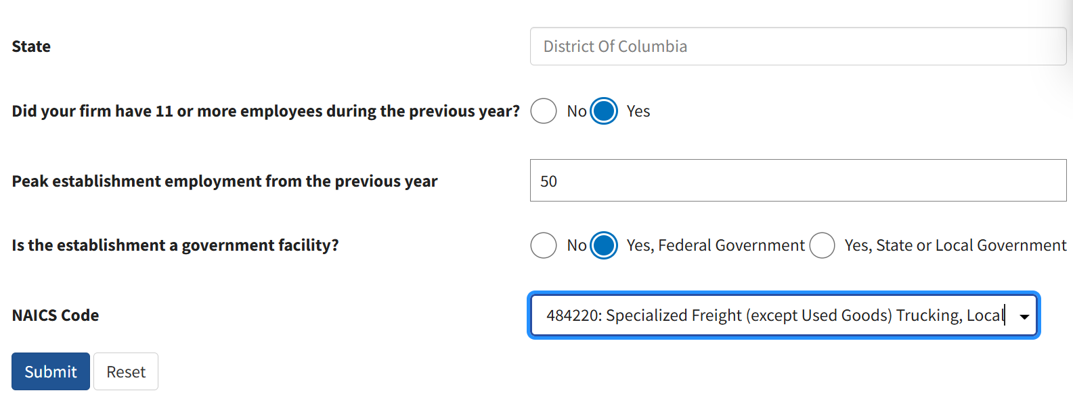  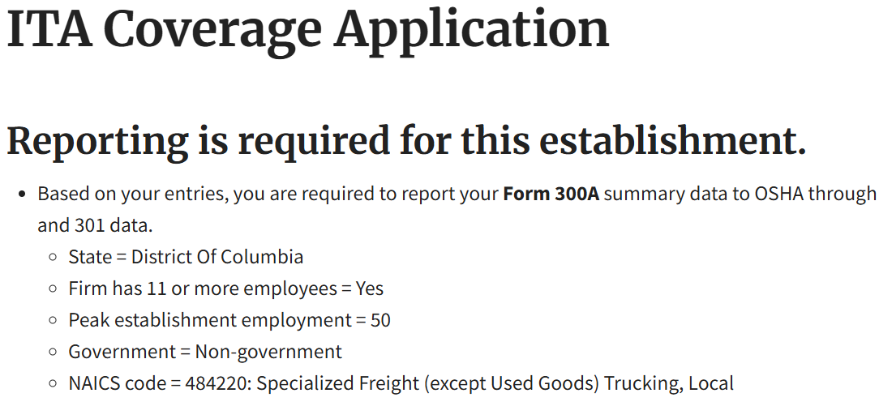
Reporter | Amogi Endurance
ID | 2
Project | ITA Coverage Application
Created | 02.05.2026
Summary | System does not validate invalid NAICS codes
Category | Validation Issue
Severity | Normal
Description | The NAICS input field accepts invalid numeric values (e.g., 666666) that are not part of the official NAICS classification list. The system does not perform validation against approved NAICS codes though it doesnt allows submission to proceed without raising any error or warning.
Steps | Enter  - State = American Samoa  - Firm has 11 or more employees = Yes  - Peak establishment employment = 120  - Government = No  - NAICS code = 666666  - Submit
Environment | Version 1.0
Attachments | 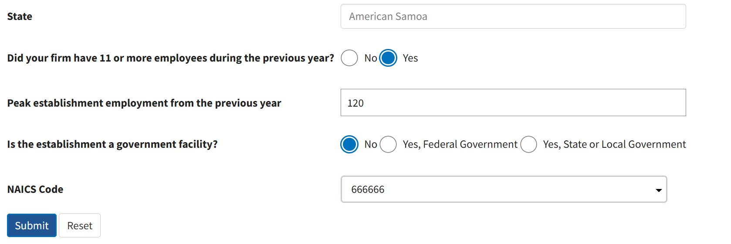
Recommendation | I recommend that a validation for the NAICS field to ensure only valid industry classification codes from the official NAICS list are accepted. This should include: user-friendly error messaging for invalid inputs
Reporter | Amogi Endurance

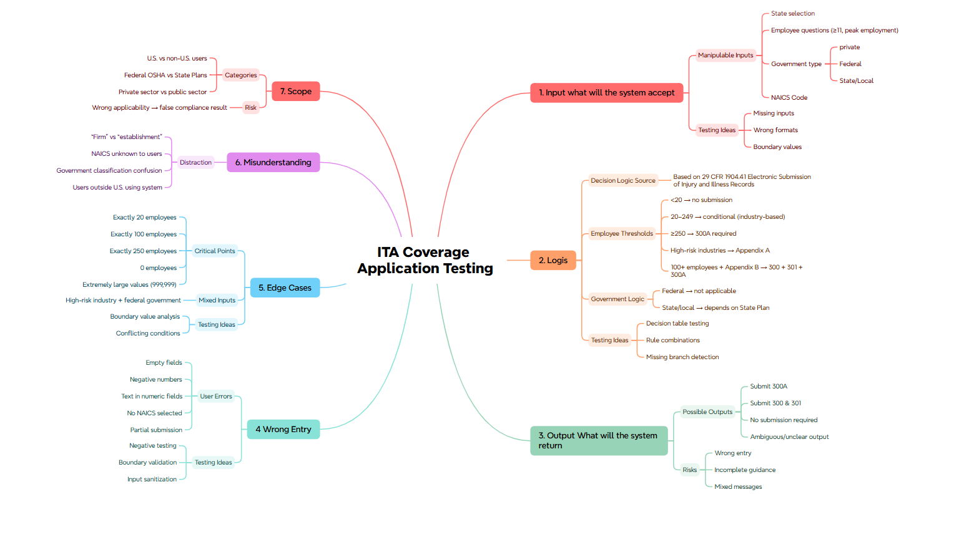
Test coverage outline

